**Safeguarding Policy including Prevent**



*Developed: February 2013*

*Last review: January 2018*

*Next review: January 2019*

Safeguarding Policy inc. Prevent

This policy outlines the framework and procedures to be carried out to safeguard young people, vulnerable adults and those at risk of radicalisation at  
Qualified Education Ltd.

## 1 Background

* 1. The Department of Education published *“Keeping children safe in education” Statutory guidance for schools and colleges* in April 2014. This document contains information on what schools and colleges should do and sets out the legal duties with which schools and colleges must comply.   
     It should be read alongside Working Together to Safeguard Children 2013.
  2. The revised guidelines make reference to “*Safeguarding and promoting welfare of children.”* Safeguarding and promoting the welfare of children is defined as *“ protecting children from mal-treatment; preventing impairment of children’s health or development; ensuring that children grow up in circumstances consistent with the provision of safe and effective care; and taking action to enable all children to have the best outcomes”*

The guidance states *“Where a child is suffering significant harm, or is likely to do so, action should be taken to protect the child. Action should also be taken to promote the welfare of a child in need of additional support, even if they are not suffering harm or at immediate risk”*

* 1. Legislation that underpins *“Keeping children safe in education” Statutory guidance for schools and colleges* that applies directly to education includes:
* The Children Act 1989 and 2004 The Education Act 2002
* The Further Education (Providers of Education) regulations 2006
* Safeguarding Vulnerable Groups Act 2006
* The Protection of Freedoms Act 2012
* The Equality Act 2010
* The Rehabilitation of Offenders Act 1974
* Counter Terrorism and Security Act 2015

1.4 At present there is no adult protection legislation in the UK, although the policy document No Secrets (2000) offers direction and guidance to Social Services to help protect 'vulnerable adults' at risk of abuse. However this is not, like child protection legislation, in statute. The aim of No secrets is to ensure that key local agencies - particularly but not solely social services, health authorities and the police - work together to protect vulnerable adults from abuse, by developing local multi-agency policies and procedures. The document provides guidance on how strategies for preventing and dealing with the abuse of vulnerable adults should be developed locally. The policy also describes principles around which agencies should develop their work. A key principle is that agencies should support individuals to live independently and make their own choices.

* 1. The purpose of the Safeguarding Vulnerable Groups Act (2006) as amended by the Protection of Freedom Act 2012 is to restrict contact between children and vulnerable adults and those who might do them harm. The level of DBS check required and whether a prohibition check is required will depend on the roles and duties of staff in an institution.

Legislation and Guidance which underpins safeguarding of vulnerable adults includes:

* Safeguarding Vulnerable Groups Act ( 2006)
* No Secrets (2000)
* Care Standards Act (2000)
* Sexual Offences Act (2003)
* Health Act (1999) includes provision for the protection of vulnerable adults
* *Prevent* Duty Guidance (2015)

1.6 The Counter-Terrorism and Security Act (2015) places a public sector duty on Colleges to have due regard to the need to prevent people from being drawn into terrorism. The *Prevent-*related responsibilities includes helping prevent people being drawn into terrorism. This includes not just violent extremism but also non-violent extremism, which can create an atmosphere conducive to terrorism and can popularise views which terrorists exploit.

1.7 All educational establishments and local authorities are subject to inspection by Ofsted, and/or other relevant inspectorates. The organisation’s performance in regard to their responsibility to safeguard and promote the welfare of children (and vulnerable adults) in accordance with the relevant legislation and guidance will form part of the inspectorate’s judgement of the organisation or establishment’s overall performance. Performance in this area will be judged by not only the existence of procedures but also by the organisation’s effectiveness in terms of safeguarding children and vulnerable adults from harm.

## 2 Key Definitions

1. **Children -** Children includes everyone under the age of 18
2. **Vulnerable Adult -** Current NHS definition of a Vulnerable Adult is:

A vulnerable adult is aged 18 or over, receives or may need community care services because of a disability, age or illness, and who is or may be unable to take care of themselves or protect themselves against significant harm or exploitation.

**From September 2012, a vulnerable adult** is defined by the Protection of Freedoms Act 2012 as a person aged 18 or over who is in receipt of **regulated activity.** This definition informs the level of DBS check required of people who provide support for adults.

1. **Regulated Activity (applies to children and vulnerable adults)**

The term **Regulated Activity** is a statutory term used to describe working or volunteering with children or vulnerable adults. Regulated activity covers anyone working closely with children or vulnerable adults, either paid or unpaid, not part of a family or personal arrangement, on a frequent, intensive or overnight basis.

**Frequent** means once a week or more (except in health or personal care services where frequent means once a month or more); **intensive** means four times in a month or overnight.

*See Appendix 1 for more information on Regulated Activities*

### 3 Definitions of Abuse and Neglect of Children (taken from Working Together to Safeguard Children 2010)

3.1 **Physical Abuse**

Physical abuse may involve hitting, shaking, throwing, poisoning, burning or scalding, drowning, suffocation or otherwise causing physical harm to a child. Physical harm may also be caused when a parent or carer feigns the symptoms of or deliberately causes ill health to a child whom they are looking after.

3.2 **Emotional Abuse**

Emotional abuse is the persistent emotional ill-treatment of a child such as to cause severe and persistent adverse effects on a child's emotional development. It may involve conveying to children that they are worthless or unloved, inadequate, or valued only insofar as they meet the needs of another person. It may feature age or developmentally inappropriate expectations being imposed on children. It may involve causing children to feel frightened or in danger, or the exploitation or corruption of children. Some level of emotional abuse is involved in all types of ill-treatment of a child, although it may occur alone. Types of emotional abuse include:

**Bullying:** Bullying is the oppression or persecution of a weaker person by a stronger person. It is sometimes included as a type of child abuse. The difference is that bullying is often inflicted by a peer rather than by an adult. However adults and older children are capable of bullying behaviour and it is frequently an element of all types of child abuse.

**Cyberbullying:** Cyberbullying is the use of Information Communications Technology (ICT), particularly mobile phones and the internet, deliberately to upset someone. It is different from other forms of bullying because: it can take place at any time and can intrude into spaces that have previously been regarded as safe or personal; the audience can be very large and reached rapidly. Cyberbullying can take place between peers and across generations and some instances of cyberbullying are known to be unintentional.

**Sexting:** Sexting is when someone sends or receives a sexually explicit text, image or video on their mobile phone, usually in a text message.

3.3 **Sexual Abuse**

Sexual abuse involves forcing or enticing a child or young person to take part in sexual activities, whether or not the child is fully aware of what is happening. The activities may involve physical contact, including penetrative (e.g. rape or buggery) or non-penetrative acts. This may include non-contact activities, such as involving children in looking at or in the production of, pornographic material or watching sexual activities, or encouraging children to behave in sexually inappropriate ways.

**Grooming** is the term used to describe how an adult gets to know a child gradually and in quite natural ways, with the intention of sexually abusing and /or exploiting them. With increased internet usage more children are being targeted for this form of abuse.

3.4 **Neglect**

Neglect is the persistent failure to meet a child's basic physical and/or psychological needs, likely to result in the serious impairment of the child's health or development. It may involve a parent or carer failing to provide adequate food or shelter and clothing, failing to protect a child from physical harm or danger, or the failure to ensure access to appropriate medical care or treatment. It may also include neglect of, or unresponsiveness to, basic emotional needs.

In addition to the categories of abuse listed, the revised guidance has identified the following as specific safeguarding issues:

* Child sexual exploitation
* Domestic violence
* Forced marriage
* Bullying (including cyber- bullying)
* FGM
* Drugs
* Fabricated or induced illnesses
* Faith abuse
* Teenage relationship abuse
* Gangs and youth violence
* Gender based violence/ violence against women and girls
* Mental health
* Private fostering
* Radicalisation
* Trafficking

*See Appendix 2 for additional information and guidance on specific safeguarding concerns*

3.5 **Abuse of position of trust**

Under the Sexual Offences Act 2003 it is an offence for a person over 18 e.g. teacher, to have a sexual relationship with a young person under 18 where that person is in a ‘position of trust’ in respect of the young person, even if the relationship is consensual.

**4 VulnerableAdults – descriptions and categories of abuse**

4.1 **Physical Abuse:** This includes hitting, slapping, pushing, kicking, rough handling or unnecessary physical force either deliberate or unintentional, misuse of medication, restraint or inappropriate sanctions.

4.2 **Sexual Abuse:** This includes rape and sexual assault or sexual acts to which the vulnerable adult has not consented, or could not consent to, or was pressured into consenting. Sexual abuse can occur between people of the same sex and it can also occur within a marriage or any long-term relationship. A relationship of trust should exist between a member of staff or a volunteer and the person for whom they are caring, it would be seen as a betrayal of that trust, and therefore abusive, for that member of staff or volunteer to have a sexual relationship with the person they are caring for. **Vulnerable adults are susceptible to grooming,** see 3.3 for definition.

4.3 **Psychological Abuse:** This includes emotional abuse, threats of abandonment or harm, deprivation of contact, humiliation, blaming, controlling, intimidation, coercion, harassment, verbal abuse, isolation or withdrawal from services or supportive networks.

4.4 **Financial or Material Abuse**: This includes theft, fraud, exploitation, pressure in connection with wills, property, enduring power of attorney, or inheritance or financial transactions, or the inappropriate use, misuse or misappropriation.

4.5 **Neglect and Acts of Omission:** This includes ignoring or withholding medical or physical care needs, failure to provide access to appropriate health, social care or educational services, the withholding of the necessities of life, such as medication, adequate nutrition, clothing and heating.

* 1. **Discriminatory Abuse:** This includes racist, sexist, or other forms that are based on a person’s disability and other forms of harassment, or similar treatment.
  2. **Institutional Abuse:** This is the mistreatment of a vulnerable adult by a regime or individuals in an institution. It can be through repeated acts of poor or inadequate care and neglect, or poor professional practice.
  3. **Domestic Violence:** When violence occurs between current or former partners within an intimate relationship, or between family members, regardless of gender or sexuality and where the victim is a vulnerable adult.
  4. **Bullying:** Bullying is the oppression or persecution of a weaker person by a stronger person and is often inflicted by a peer rather than by an adult.
  5. **Cyberbullying:** Refer to 3.2

*See Appendix 3 for Indicators of Abuse*

*See Appendix 4 for Additional Information on Cyberbullying*

## 5. Prevent – related responsibilities

**5.1 Partnership.**

Qualified Education Ltd will actively engage members of staff, learners and other partners (including the police and *Prevent* Co-ordinators) to implement best practice in supporting its learners. Our aim is to prevent learners from being radicalised and drawn into extremism, which terrorist organisations may exploit /or being exploited by terrorist organisations.

**5.2 Risk assessment**

Qualified Education Ltd will carry out a risk assessment which assesses where and how learners or staff may be at risk of being drawn into terrorism. Qualified Education Ltd will review its policies and procedures, in response to identified risks. Qualified Education Ltd will prioritise reviewing the policies and procedures for events held by staff, learners or visitors and relationships with external bodies who may use Qualified Education Ltd premises or work in partnership with the institution. Key risks and control measures will be reflected in the Risk Register.

**5.3 Action Plan**

Qualified Education Ltd will inform the local Prevent co-ordinator of any identified risks and the action it plans to take to mitigate the risks.

**5.4 Staff training**

Qualified Education Ltd will demonstrate that managers, teachers and assessors undertake appropriate training and are able to identify learners who may be vulnerable to being drawn into extremism and possibly terrorism. Training for teachers and staff involved in supporting learning will include the importance of exemplifying British values and reinforcing the importance of respecting other people with particular regard to the protected characteristics set out in the Equalities Act 2010. Procedures for sharing concerns and referrals to Channel programmes will be incorporated into the training.

**5.5 IT policies**

Qualified Education Ltd will review IT policies and procedures to ensure that they make reference to the Prevent duty guidance.

## 6 Policy

This policy represents Qualified Education Ltd’s response to its role in safeguarding the welfare of learners and other young people under 18 and vulnerable adults.

* 1. Qualified Education Ltd will set up clear procedures with designated members of staff in charge of these procedures within Qualified Education Ltd (Appendix 1A).
  2. Qualified Education Ltd will ensure the learner’s wishes or feelings are taken into account when determining what action to take and what services to provide to protect them. This will be done by ensuring the learner has the opportunity to speak to a member of staff who is involved in making decisions about action which may happen.

6.3 Qualified Education Ltd will work co-operatively with external agencies such as the police, Prevent Co-ordinators and Social Services.

6.4 Qualified Education Ltd will ensure that learners are offered the support they require. Resources are made available to tutors to use at induction and during the year. Learners may be signposted to counselling and referred to outside agencies if necessary.

6.5 The staff of Qualified Education Ltd will work towards ensuring the curriculum offers information and support for issues of safeguarding.

6.6 Qualified Education Ltd will ensure that all staff, as part of staff development (including staff working for contracted out services) receive appropriate training to ensure that they are able to recognise the signs and symptoms of abuse. In addition all staff will be made fully aware of the procedures for reporting and recording their concerns. Qualified Education Ltd will deliver training on radicalisation and the action that must be taken if there is a concern that a member of Qualified Education Ltd community may be drawn into terrorism.

6.7 Qualified Education Ltd will monitor and review annually the Safeguarding Policy and Procedures as part of its equality initiatives.

6.8 Qualified Education Ltd will ensure that all recruitment checks, as outlined in the Safer Recruitment in Education Guidelines (Jan 2007), are carried out.

6.9 Qualified Education Ltd will recommend and disseminate its “Code of Conduct” for staff working with young people and vulnerable adults for all staff as outlined in guidance published by Government Offices for the English region.

## 7 Procedures

7.1 The Centre Director shall be Qualified Education Ltd's "Designated Senior Person”.

7.2 Looked after Children: Learners will be given the opportunity to declare their Looked After/Care Leaver status at all stages of the recruitment and enrolment process; during induction and while on course. Additional support will be offered to learners who fall into these categories by the Careers and Learner Advice teams. The Centre Director shall be Qualified Education Ltd's "Designated Teacher” for Looked After children

7.3 Missing Children: In the case of missing children Qualified Education Ltd will work with statutory agencies to ensure the safety of the missing child.

7.4 Learners undertaking on Work Placements: Qualified Education Ltd will have policies and procedures in place to protect learners from harm when they are on work placement.

7.5 The Centre Director will be responsible for overseeing this policy and related procedures and to liaise with partner agencies. This will be supported by the Qualifications Manager

7.7 If a young person or vulnerable adult discloses abuse to any member of staff details of the disclosure must be recorded on the *Safeguarding* *Concern Form* (Appendix 6) and the member of staff must refer the learner to the person. This also includes situations of abuse which may involve staff members. If the Centre Director is not available colleagues must refer the learner to the Qualifications Manager. (Appendix 5)

7.8 The Safeguarding Concern form should also be used to record concerns about a learner who may be at risk of radicalisation. The Designated Senior Person will follow the processes within FE Colleges on receipt of a referral. See Appendix 5

7.9 Although the revised guidelines highlight that ***“if at any point, there is a risk of immediate serious harm to a child a referral should be made to Children’s Social Care immediately. Anybody can make a referral”.*** Details of all referrals must be shared with the designated safeguarding team.

7.10 If any member of staff suspects that a young person or vulnerable adult is being abused they should record their concerns on the *Concern Form* then discuss this in the first instance with the Centre Director.

7.11 All complaints, allegations or suspicions must be taken seriously.

7.12 Absolute promises of confidentially should **not** be given as the matter may develop in such a way that these might not be able to be honoured.

7.13 If the complaint comes directly from the child/adult, questions should be kept to the minimum necessary to understand what is being alleged and care is taken to avoid leading questions. Unnecessary questioning could jeopardise future legal proceedings.

7.14 Issues regarding the safeguarding of young people and vulnerable adults should be included within the tutorial programme.

7.15 Safeguarding training is mandatory for all new members of staff, it is covered during induction.

7.16 (1) Mandatory safeguarding training will include information on radicalisation and extremism. Additionally all members of staff will be required to attend a dedicated Workshop to Raise Awareness of Prevent (WRAP).

7.17 Any concern should be noted on the Safeguarding Concern Form (Appendix 6) and emailed to [georgina@qualified-education.co.uk](mailto:safeguarding@cwc.ac.uk) to be kept in a safe and secure place for a minimum of seven years.

7.18 Learners who are found to have placed other learners or staff “At Risk” will face disciplinary action in accordance with the Code of Conduct and Disciplinary procedures.

The procedures laid out in this document must be followed whenever an allegation is made that a child/adult has been abused.

## 8 Procedure for Allegations Against Staff

8.1 Allegations of abuse against a member of staff must be referred to the Designated Senior Person as soon as possible and in any case within 2 hours of the initial concern arising. Disciplinary procedures should be followed. Qualified Education Ltd will inform the Local Authority Designated Officer (LADO) of any allegations that might indicate a person would pose a risk of harm to children.

8.2 All allegations and investigations against members of staff will be conducted in line with legislation and good practice outlined in the revised statutory guidance “Keeping children safe in education.”

8.3 When conducting an investigation involving a safeguarding issue (where the alleged victim is under 18 or a vulnerable adult) the investigating officer must take guidance from the Designated Senior Person in relation to the interviewing procedure to be followed and where there is significant risk learner interviews could be conducted by the Designated Senior Person or the Qualifications Manager.

8.4 The Designated Senior Person may decide to stop proceedings and refer the case to the police for further investigation where this is deemed necessary.

8.5 If a member of staff is dismissed or removed from “regulated activity” (or would have been had they not already left) because they harmed or posed a risk of harm to vulnerable groups including children, Qualified Education Ltd will be under a legal obligation to forward information about that person to the ISA. It is the ISA’s responsibility to make a decision on the barring or not of any individual. The member of staff may make representation to the ISA against being barred.

## 9 Procedure for Monitoring and Reviewing Policy and Procedures

9.1 The Centre Director and Qualifications Manager will monitor and review their practice termly.

9.2 A formal report will be made annually by the Designated Senior Person on numbers of interventions and, if appropriate, outcomes of any interventions. The report will be limited in its content to ensure the protection of those involved.

###### ***10*** ***Personnel Recruitment Procedure***

Applicants are required to complete an application form (which may lead to a subsequent interview) which contains explicit information about their past. These are required to be returned to the relevant department and the member of personnel managing the recruitment process.

Where applicants will take significant responsibility for safeguarding children during activities within Qualified Education Ltd, they will be required to complete an Enhanced Disclosure and Barring (DBS) check.

Personnel are selected on their suitability to meet the job/role-related requirements and responsibilities and their ability to demonstrate that they can work safely with children and/or vulnerable adults.

Applicants will receive confirmation in writing relating to the outcome of their application/interview. If the outcome is positive, arrangements are made for induction and any relevant training, which includes clarification of activity requirements, responsibilities and child and vulnerable adult protection procedures and further identification of training needs.

New members of personnel are then required to confirm their agreement to abide by the Qualified Education Ltd policies and procedures, including the child and vulnerable adult protection policy, in writing. Awareness of child and vulnerable protection practice will continue to be addressed via ongoing training. All members of personnel who work with children and vulnerable adults are required to adhere to this policy.

**Related College Policies:**

### At Risk Strategy

* Anti- bullying Policy (Learners)
* Bullying and Harassment Policy
* Code of Conduct for Staff
* Staff Disciplinary Policy
* Drugs Policy
* Disability Statement
* Equal Opportunities Policy (included in the Single Equality Scheme)
* Learner Mental Health Policy and Procedures
* Trips and Visits Policy
* Disciplinary Policy and Procedures

**Useful Website:**

* [www.nspcc.org.uk](http://www.nspcc.org.uk)

**Appendix 1**

**Information on REGULATED ACTIVITIES**

**A Regulated Activity** may be a role that is carried out frequently or intensively or overnight in any of the following **specified** settings:

* Schools (educational institutions exclusively or mainly for the provision of full time education to under-18s)
* Pupil referral units
* Childcare premises (including nurseries)
* Residential homes for children in care
* Children’s hospitals (hospitals exclusively or mainly for the reception and treatment of children)
* Children’s detention centres (institutions exclusively or mainly for the detention of children)
* Children’s centres in England and Wales, and
* Adult care homes (residential care or nursing homes in Northern Ireland).

Regulated activity can also include any of the following specified activities:

* Teaching, provided wholly or mainly for children and vulnerable adults
* Training, provided wholly or mainly for children or vulnerable adults
* Supervising
* Advice
* Treatment, or
* Transport

**To be eligible to request an Enhanced DBS check a position must meet both the definition of the activity and meet the frequency or intensive test**. It cannot be Regulated Activity if it does not meet both conditions.

For DBS purposes a vulnerable adult is a person who is aged 18 years or older and:

* is living in residential accommodation, such as a care home or a residential special school;
* is living in sheltered housing;
* is receiving domiciliary care in his or her own home;
* is receiving any form of health care;
* is detained in a prison, remand centre, young offender institution, secure training centre or attendance centre or under the powers of the Immigration and Asylum Act 1999;
* is in contact with probation services;
* is receiving a welfare service of a description to be prescribed in regulations;
* is receiving a service or participating in an activity which is specifically targeted at people with age-related needs, disabilities or prescribed physical or mental health conditions or expectant or nursing mothers living in residential care (age-related needs includes needs associated with frailty, illness, disability or mental capacity);
* is receiving direct payments from a local authority/HSS body in lieu of social care services;
* requires assistance in the conduct of his or her own affairs.

In order for eligibility to exist in this case the role must meet the eligibility criteria for Regulated Activity. This means working in the **same specified place**, working **frequently** (once a week or more) and **having the opportunity to have contact with children or vulnerable adults** or carrying out a **specified activity, frequently.** If this is the case then eligibility would exist.

**Appendix 2**

## This list has been taken from “Keeping children safe in education”.

## Specific safeguarding issues

25. Expert and professional organisations are best placed to provide up-to-date guidance and practical support on specific safeguarding issues. For example NSPCC offers information for schools and colleges on the TES website and also on its own website [www.nspcc.org.uk](http://www.nspcc.org.uk/)  Schools and colleges can also access broad government guidance on the issues listed below via the GOV.UK website:

* [child sexual exploitation (CSE) –](https://www.gov.uk/government/publications/what-to-do-if-you-suspect-a-child-is-being-sexually-exploited) see also below
* [bullying including cyberbullying](https://www.gov.uk/government/publications/preventing-and-tackling-bullying)
* [domestic violence](https://www.gov.uk/domestic-violence-and-abuse)
* [drugs](https://www.gov.uk/government/publications/drugs-advice-for-schools)
* [fabricated or induced illness](https://www.gov.uk/government/publications/safeguarding-children-in-whom-illness-is-fabricated-or-induced)
* [faith abuse](https://www.gov.uk/government/publications/national-action-plan-to-tackle-child-abuse-linked-to-faith-or-belief)
* [female genital mutilation (FGM)](https://www.gov.uk/government/publications/female-genital-mutilation-multi-agency-practice-guidelines) – see also below
* [forced marriage](https://www.gov.uk/forced-marriage)
* [gangs and youth violence](https://www.gov.uk/government/uploads/system/uploads/attachment_data/file/226293/Advice_to_Schools_and_Colleges_on_Gangs.pdf)
* [gender-based violence/violence against women and girls (VAWG)](https://www.gov.uk/government/policies/ending-violence-against-women-and-girls-in-the-uk)
* [mental health](https://www.gov.uk/government/publications/the-mental-health-strategy-for-england)
* [private fostering](https://www.gov.uk/government/publications/children-act-1989-private-fostering)
* [radicalisation](https://www.gov.uk/government/publications/channel-guidance)
* [sexting](http://ceop.police.uk/)
* [teenage relationship abuse](https://www.gov.uk/government/collections/this-is-abuse-campaign)
* [trafficking](https://www.gov.uk/government/publications/safeguarding-children-who-may-have-been-trafficked-practice-guidance)

**Key points:**

## Domestic violence and abuse: new definition

Domestic violence and abuse is:

any incident or pattern of incidents of *controlling, coercive, threatening behaviour, violence or abuse* between **those aged 16 or over who are**, or have been, intimate partners or family members regardless of gender or sexuality. The abuse can encompass, but is not limited to:

* psychological
* physical
* sexual
* financial
* emotional

### Controlling behaviour

Controlling behaviour is a range of acts designed to make a person subordinate and/or dependent by isolating them from sources of support, exploiting their resources and capacities for personal gain, depriving them of the means needed for independence, resistance and escape and regulating their everyday behaviour.

### Coercive behaviour

Coercive behaviour is an act or a pattern of acts of assault, threats, humiliation and intimidation or other abuse that is used to harm, punish, or frighten their victim.

## Domestic abuse and young people

The changes to the definition of domestic raise awareness that young people in the 16 to 17 age group can also be victims of domestic violence and abuse.

By including this age group the government hopes to encourage young people to come forward and get the support they need, through a helpline or specialist service.

## Forced marriage

A forced marriage is where one or both people do not (or in cases of people with learning disabilities, cannot) consent to the marriage and pressure or abuse is used. It is an appalling and indefensible practice and is recognised in the UK as a form of violence against women and men, domestic/child abuse and a serious abuse of human rights.

The pressure put on people to marry against their will can be physical (including threats, actual physical violence and sexual violence) or emotional and psychological (for example, when someone is made to feel like they’re bringing shame on their family). Financial abuse (taking your wages or not giving you any money) can also be a factor.

**Child abuse linked to faith or belief**

Abuse linked to belief, including belief in witchcraft or possession, is a horrific crime which is condemned by people of all cultures, communities and faiths.

Standard child safeguarding procedures apply in all cases where abuse or neglect is suspected, including those that may be related to particular belief systems.

The number of cases of child abuse linked to faith or belief in spirits, possession and witchcraft is believed to be small, but where it occurs it causes much distress and suffering to the child. It is likely that a proportion of this type of abuse remains unreported.

Abuse linked to faith or belief may involve a wider context, where the child is treated as a scapegoat in circumstances of family stress, deprivation, domestic violence, substance abuse and mental health problems.

**Mental health difficulties can increase a person’s vulnerability**

***Mental health difficulties – the statistics***

At least one in four people will experience a mental health difficulty at some point in their life and one in six adults has a mental health problem at any one time.

One in ten children aged between 5 and 16 years has a mental health difficulty, and many continue to have mental health difficulties into adulthood.

Half of those with lifetime mental health difficulties first experience symptoms by the age of 14, and three-quarters before their mid-20s.

Self-harming in young people is not uncommon (10–13% of 15–16-year-olds have self-harmed).

Almost half of all adults will experience at least one episode of depression during their lifetime.

One in ten new mothers experiences postnatal depression.

About one in 100 people has a severe mental health difficulty.

Some 60% of adults living in hostels have a personality disorder.

Some 90% of all prisoners are estimated to have a diagnosable mental health difficulty

(including personality disorder) and/or a substance misuse problem.

**Child sexual exploitation (CSE)** involves exploitative situations, contexts and relationships where young people receive something (for example food, accommodation, drugs, alcohol, gifts, money or in some cases simply affection) as a result of engaging in sexual activities.

Sexual exploitation can take many forms ranging from the seemingly ‘consensual’ relationship where sex is exchanged for affection or gifts, to serious organised crime by gangs and groups. What marks out exploitation is an imbalance of power in the relationship.

The perpetrator always holds some kind of power over the victim which increases as the exploitative relationship develops. Sexual exploitation involves varying degrees of coercion, intimidation or enticement, including unwanted pressure from peers to have sex, sexual bullying including cyberbullying and grooming. However, it also important to recognise that some young people who are being sexually exploited do not exhibit any external signs of this abuse.

**Female Genital Mutilation (FGM**): professionals in all agencies, and individuals and groups in relevant communities, need to be alert to the possibility of a girl being at risk of FGM, or already having suffered FGM. There is a range of potential indicators that a child or young person may be at risk of FGM, which individually may not indicate risk but if there are two or more indicators present this could signal a risk to the child or young person.

Victims of FGM are likely to come from a community that is known to practise FGM. Professionals should note that girls at risk of FGM may not yet be aware of the practice or that it may be conducted on them, so sensitivity should always be shown when approaching the subject. Warning signs that FGM may be about to take place, or may have already taken place, can be found on pages 11-12 of the Multi-Agency Practice Guidelines referred to previously. Staff should activate local safeguarding procedures, using existing national and local protocols for multi-agency liaison with police and children’s social care.

**Appendix 3**

**Possible indicators of abuse of teenagers**

It can be harder to spot signs of abuse in teenagers than in younger children or vulnerable adults as teenagers are more capable of covering up injuries; however it is important that staff are aware of changes in a learner’s behaviour, attendance or attitude to their work as the changes could be indicators of abuse.

Possible indicators of abuse in teenagers

* Poor self esteem
* Depression and anxiety
* Tiredness due to sleep disturbance
* Not eating, weight loss or weight gain
* Marked changes in attendance at College, unexplained absences from college, lengthy absences from college
* Marked changes in behaviour, learners becoming withdrawn or aggressive
* Pregnancy
* STD

**Possible indicators of abuse of vulnerable adults**

Some Possible Indicators of physical abuse:

* unexplained skin bruising
* unexplained cuts or abrasions
* unexplained burns
* unexplained fractures etc

However, please remember some physiological processes/medical conditions can cause changes which are hard to distinguish from some aspects of physical abuse.

Some possible indicators of neglect:

* poor hygiene
* malnutrition
* inappropriate clothing
* broken skin

Some possible psychological and emotional indicators:

* withdrawal
* depression
* cowering and fearfulness
* sudden changes in behaviour
* deliberate self-harm

Some possible indicators of sexual abuse:

* unexplained marked fluctuation of mood changes
* urinary infection
* pain, bruising or bleeding in genital or anal areas
* inappropriate sexually related activities/behaviour

Some general indicators which may suggest abuse:

* seeking shelter or protection
* unexplained reactions towards particular settings
* frequent or regular visits to the GP, or hospital casualty department, or hospital admissions
* frequent or irrational refusal to accept investigations or treatments for routine difficulties
* inconsistency of explanation

The following "trigger" behaviours may be additional indicators that abuse is occurring:

* destruction of physical environment
* turning night into day/sleep disturbance
* chronic incontinence
* extreme physical and/or emotional dependence
* verbal abuse and aggression towards the carer
* changes in personality – caused by illness and/or medication
* noncompliance with carer’s wishes
* obsessive behaviour
* wandering/absconding
* self-harm

***Appendix 4***

**Additional Information on Cyberbullying**

|  |  |
| --- | --- |
| **Technology** | **Example of Misuse** |
| Mobile phones | Sending nasty calls or text messages, including threats. Intimidation or harassment. Taking and sharing humiliating images. Videoing other people being harassed and sending these to other phones or internet sites |
| What’s App  Snap Chat | Sending inappropriate messages or content. |
| Email | Sending inappropriate, nasty or threatening messages. Forwarding unsuitable content including images and video clips, or sending computer viruses. Accessing someone else’s account, e.g. to forward personal emails or delete emails. |
| Webcams | Making and sending inappropriate content. Persuading or threatening young people to act in inappropriate ways. Using inappropriate recordings to manipulate young people. |
| Social network sites e.g.  Facebook, Twitter, Instagram and  Internet dating sites (e.g. Tinder) | Posting nasty comments, humiliating images / video.  Accessing another person’s account details and sending unpleasant messages, deleting information or making private information public. Groups of people picking on individuals by excluding them. Creating fake profiles to pretend to be someone else, e.g. to bully, harass or get the person into trouble  Trolling (posting inflammatory, extraneous, or off-topic messages in an online community with the deliberate intent of provoking the account holder)  Vulnerable people may be exploited through relationships established on internet-dating sites |
| You tube | Posting embarrassing, humiliating film of someone. |
| Virtual Learning  Environments | Posting inappropriate messages or images. Hacking into someone else’s account to post inappropriate comments or delete schoolwork. |
| Gaming sites,  consoles and  virtual worlds | Name-calling, making abusive / derogatory remarks. Players may pick on weaker or less experienced users, repeatedly killing their characters.  Forwarding unwanted messages to other devices in the immediate vicinity. |
| Identity Theft | Bank details and other personal information being stolen and used inappropriately |

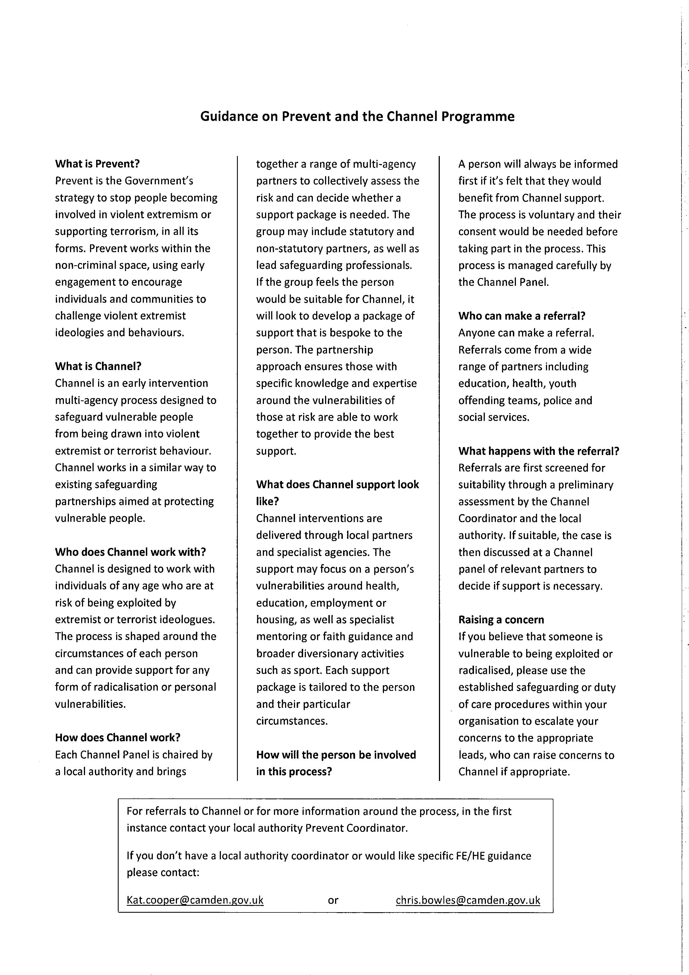

***Appendix 5***

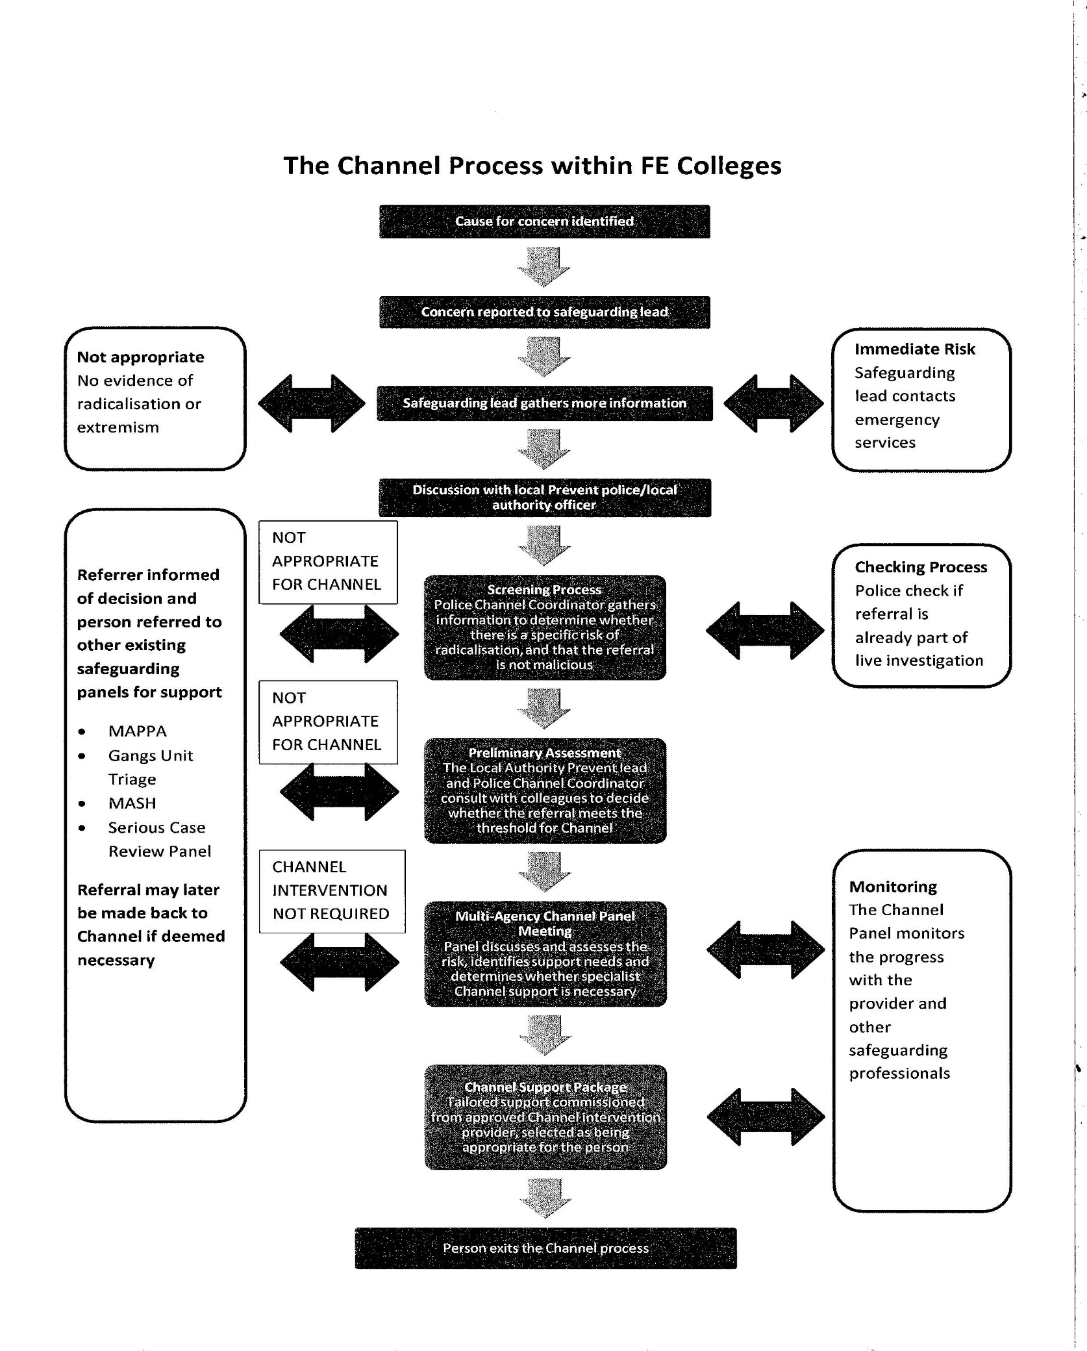

**Appendix 6**

**SAFEGUARDING: NOMINATED MEMBERS OF STAFF**

**WHAT TO DO IF A LEARNER DISCLOSES AN ISSUE INVOLVING ABUSE OR IF YOU HAVE A SAFEGUARDING CONCERN**

|  |  |  |
| --- | --- | --- |
| Learner discloses an issue involving abuse to member of staff or  Staff member has a safeguarding cause for concern | | |
|  |  |  |
| **Staff member is required to:**   * Inform Centre Director immediately, or at earliest opportunity. If the Centre Director is unavailable, please contact the Qualifications Manager. * Fill in the Safeguarding Concern Form and pass to the Centre Director or Designated Senior Person. Do not ask learner leading questions or ask for details.   **Acknowledge, listen, record and refer**   * Record conversation on concern form using exact words and contexts * Sign and date form and email to georgina@qualified-education.co.uk | | |
|  |  |  |
| **By doing the above you have fulfilled your obligations. You should not discuss the issue any further with the learner once the referral has been made** | | |
|  |  |  |

**Appendix 6**

**SAFEGUARDING CONCERN FORM**

To: ………………………………………………………….. Date of referral: ……………………………

From: …………………………………………………… Job title: ……………………………….……

Name of Learner: …………………………………………………………………………………………….

D.O.B: …………………………………… Course: ………………………………………………………..

Learners phone number: …………………………….. Tutor: ………………………………………...

Nature of Concern: …………………………………………………………………………………………..

…………………………………………………………………………………………………………………….

…………………………………………………………………………………………………………...............

……………………………………………………………………………………………………………………

Action Taken: …………………………………………………………………………………………………

…………………………………………………………………………………………………………..............

……………………………………………………………………………………………………………………

……………………………………………………………………………………………………………………

Agencies involved? If so give Name and Contact details: ………………………………………..

…………………………………………………………………………………………………………………..

…………………………………………………………………………………………………………………..

…………………………………………………………………………………………………………………..

Signed: ………………………………………………………. Dated: …………………………………….

**Appendix 7**

**INFORMATION FROM NORFOLK SAFEGUARDING ADULTS TEAM**

Your Safeguarding Adults Team who can be contacted for advice and information via Tel: **0344 800 8020**

* **Norfolk Safeguarding Adults Team Manager**

**Helen Thacker**

* **Multi-Agency Safeguarding Hub (MASH)**

**Wendy Masters, Safeguarding Adults Practice Consultant**

**Toby Thouless, Safeguarding Adults Practice Consultant**

* **Central Locality**

**Dee Blakey, Safeguarding Adults Practice Consultant**

**Useful Telephone Numbers**

|  |  |
| --- | --- |
| **Care Quality Commission** (CQC) | 03000 616161 |
| **Police:**   * Emergency * Non-Emergency | 999  101 |
| **MASH (**Multi-Agency Safeguarding Hub**)** | 0344 800 8020 |
| **Health:**   * Debbie Beresford – Safeguarding Adults Lead, Norfolk Community Health & Care * Dawn Collins, Safeguarding Adults Lead, Norfolk & Norwich University Hospital, Norwich * Howard Stanley– Safeguarding Adults Lead, Norfolk Clinical Commissioning Groups (CCG’s) * Gerry Green, Safeguarding Adults Lead, Queen Elizabeth Hospital, Kings Lynn * Julia Hunt – Chief Matron, James Paget Hospital, Gorleston * Walter Lloyd-Smith – Safeguarding Adults Lead, East Cost Community Health Care CIC * Jackie Schneider - Head of Quality & Patient Safety, North Norfolk Clinical Commission Group (CCG) | 01603 776776  01603 646028  01603 257030  Mob: 07939099002  01553 613613  01493 452452  01493 334113  01263 738100 |
| **NHS and Social Care Whistleblowing Helpline** | 08000 724725 |

|  |  |
| --- | --- |
| **Mental Health:**   * Saranna Burgess – Safeguarding Lead, Norfolk & Suffolk NHS Foundation Trust | 01603 421311 |
| **Quality Assurance:**   * Roger Morgan | 01603 223988 |
| **Domestic Violence:**   * Domestic Violence Unit, Norfolk Constabulary | 01603 276339 |
| **Hate Crime:**   * Emergency * Non-Emergency * Text * Refer via website – link below   <http://www.norfolk.gov.uk/Community_and_living/Equality_and_strong_communities/Hate_Free_Norfolk/index.htm> | 999  101  07786 200777 |
| **Other Authorities:**  Cambridgeshire   * Cambridgeshire Direct   Lincolnshire   * Lincolnshire Safeguarding Adults Team * Emergency Duty Team   Suffolk   * Suffolk Safeguarding Adults Team | 0345 0455202  01522 782155  01522 782333  0808 8004005 |

***Appendix A***

**Referrers Checklist - Tel: 0344 800 8020**

This Checklist is to assist you to have adequate information when you are making a referral as we know that it is often a very stressful conversation and you may forget vital information when you make the call. Referrals will be considered when some of this information is not available.

|  |  |  |
| --- | --- | --- |
|  | **Essential** | **Desirable** |
| **Name of Alerter** (Youcan remain anonymous) |  |  |
| **Contact details of Alerter** |  |  |
| **Relationship to Victim** |  |  |
| **Organisation of Alerter** |  |  |
|  |  |  |
| **Name** (of Vulnerable Adult) |  |  |
| **Address of Vulnerable Adult** |  |  |
| **Address, if different, of place of alleged abuse** |  |  |
| **Contact details of Vulnerable Adult** |  |  |
| **Details of Category of Vulnerability** (Older, frail, Mental Health, Learning Difficulties etc.) |  |  |
| **Date of Birth or Age** |  |  |
| **Gender** |  |  |
| **Ethnicity** |  |  |
| **Religion** |  |  |
| **Capacity and understanding** |  |  |
| **Communication needs** (sensory loss, Language, other) |  |  |
| Name of Alleged Perpetrator |  |  |
| Address of Alleged Perpetrator |  |  |
| Date of Birth of Alleged Perpetrator |  |  |
|  |  |  |
| **Details of Referral -** You need to consider the following so that the person taking the referral can gain adequate information |  |  |
| **Nature of abuse/incident** |  |  |
| **When did it happen?** |  |  |
| **Where did it happen?** |  |  |
| **Was anyone else involved?** |  |  |
| **Was the incident witnessed?** |  |  |
| **Have you had previous concerns regarding this person? If so what?** |  |  |
| **Does the vulnerable adult know you are making this referral?** |  |  |
| **Have you done anything to assist the Vulnerable Adult at this time? (**What actions have been taken?) |  |  |
|  |  |  |
| **How do you want to be contacted in the future?** |  |  |

***Appendix C***

**SAFEUGARDING ADULTS – WHAT TO RECORD**

**RECORDING TEMPLATE**

|  |  |  |  |
| --- | --- | --- | --- |
|  | **Detail** | **Date** | **Time** |
| Initial discussion with |  |  |  |
| Referral (if made) |  |  |  |
| Strategy discussion   * With whom |  |  |  |
| Action Required   * By whom |  |  |  |

***Appendix D***

***Body Map***



* Injuries deemed to be serious, would be those more serious than:

Grazes, abrasions, minor bruising, reddening of the skin, superficial cuts etc.

**In any case where the circumstances dictate that the Police are notified**

**DO NOT DELAY – Evidence can be lost!**

Refer to Norfolk Adult Social Services 0344 800 8020

Yes

Ring 999

No

**Section 2**

**Useful Links**

Link to

* Norfolk Safeguarding Adults Policy
* Norfolk Safeguarding Adults Procedures
* Norfolk Safeguarding Adults Legislative Guidance

<http://www.norfolk.gov.uk/Adult_care/Keeping_safe/Safeguarding_adults/NCC115071>

Link to

* Useful Further Information
* Safeguarding Adults Leaflet
* Poster
* New Letters
* Reports

<http://www.norfolk.gov.uk/Adult_care/Keeping_safe/Safeguarding_adults/NCC115061>

Link to

* Disclosure and Barring Service guidance and referral form

<https://www.gov.uk/government/organisations/disclosure-and-barring-service>

Link to

* Hate crime in Norfolk

<http://www.norfolk.gov.uk/Community_and_living/Equality_and_strong_communities/Hate_Free_Norfolk/index.htm>